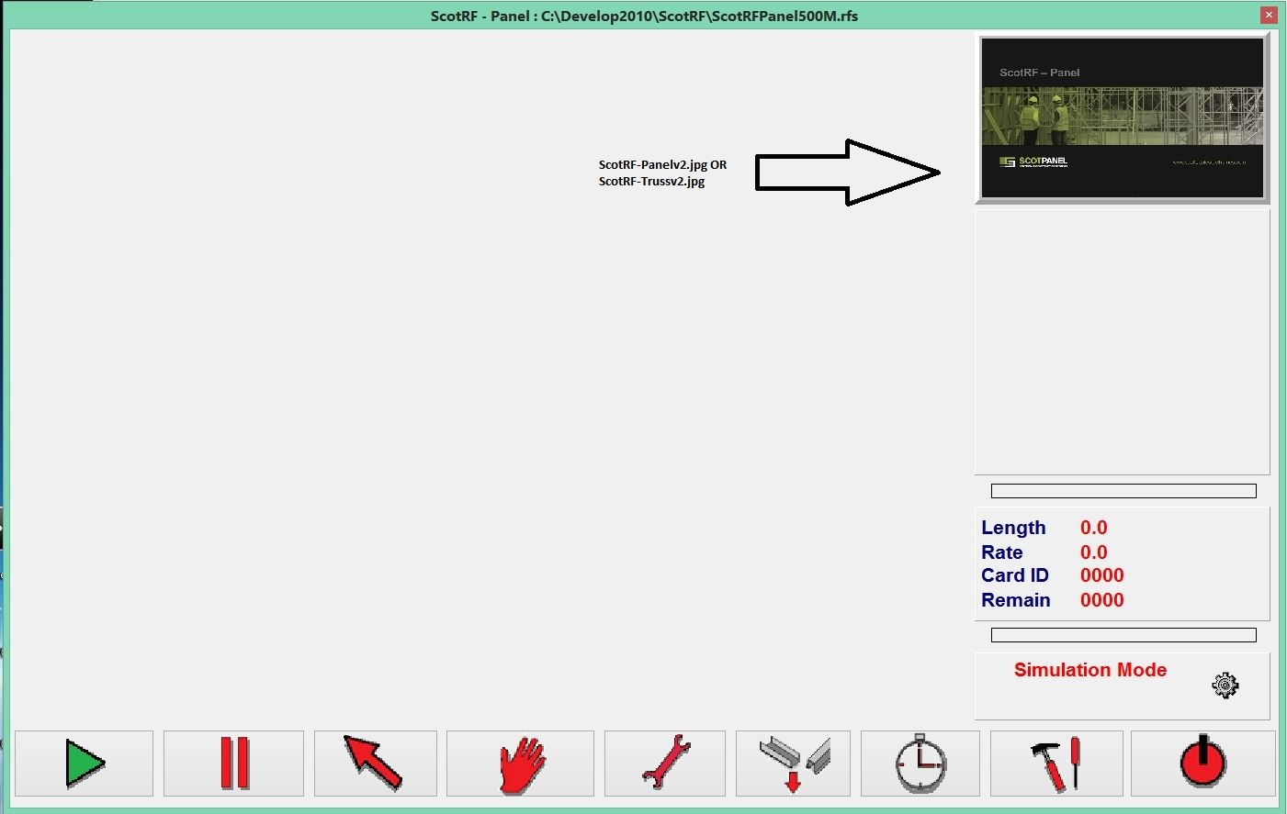

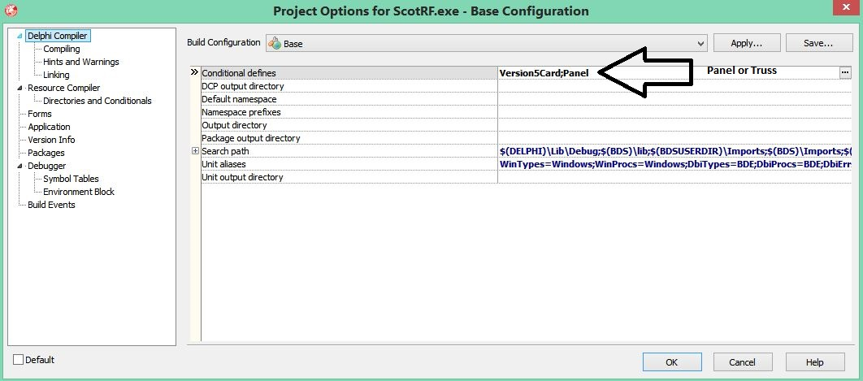

Hi Martin,

Thanks for taking the time to visit today.

Attached are a couple of screen shots showing how the version is changed for Panel or Truss releases.

The image on the mainform could be loaded at runtime from a jpg, but I stopped this as customers were putting there own logos into our software.

You might want to revisit that to avoid having to reload the jpg for Panel or Truss versions.

Meant to mention that the latest Mint drive comms uses an OCX provided by Baldor, and the smartcard comms uses a DLL provided by the card reader people.

Let me know if you need anything else.

I will send the development folder in a separate email.

Cheers

Pete

Switched DCUs to sub folder

SVN-Delete \*.dcu

remove scottsdale.bpl

move third party packages to projects

C:\Users\Public\Documents\RAD Studio\7.0\3rdParty and install 'allPackages'

Also install C:\Program Files (x86)\Embarcadero\RAD Studio\7.0\bin\ dclsockets140.bpl